**Lab report #4**

**Sadovskaya Veronika**

GitHub: https://github.com/sdveronika/DataMola22

Create all necessary tables for the cleansing area from the DW_CL user in the ts_dw_cl tablespace:

1. create table dw_cl.cl_t_client

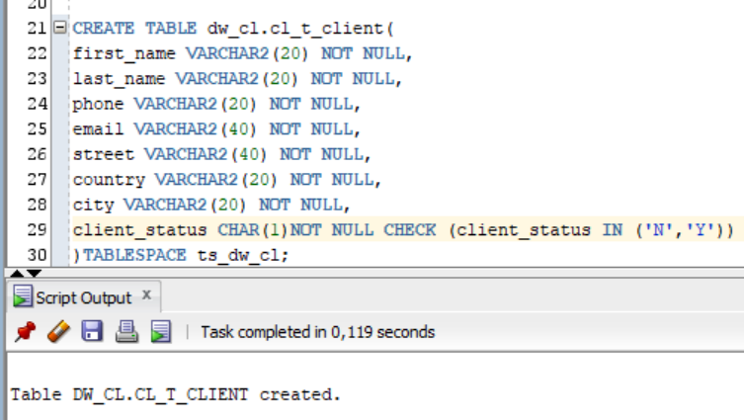

1. create table dw_cl.cl_t_dish

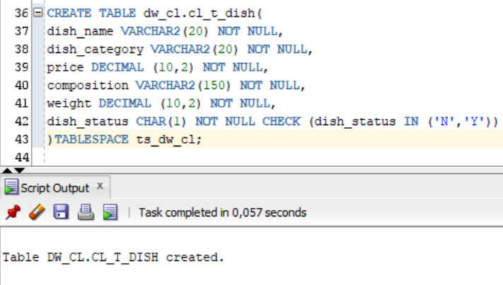

1. create table dw_cl.cl_t_employee

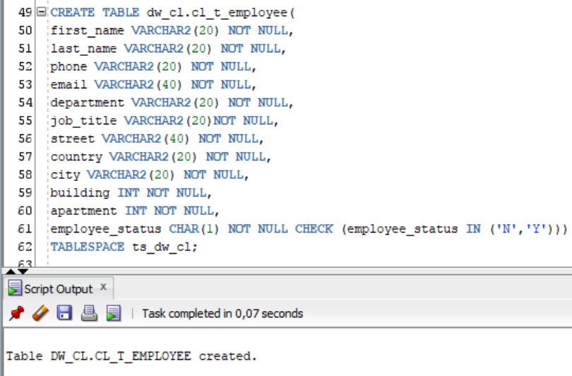

1. create table dw_cl.cl_t_gen_period

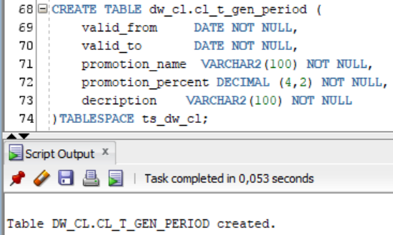

1. create table dw_cl.cl_t_payment_method

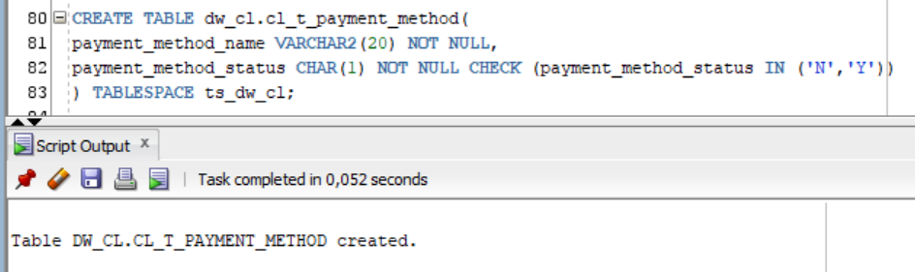

1. create table dw_cl.cl_t_restaurant

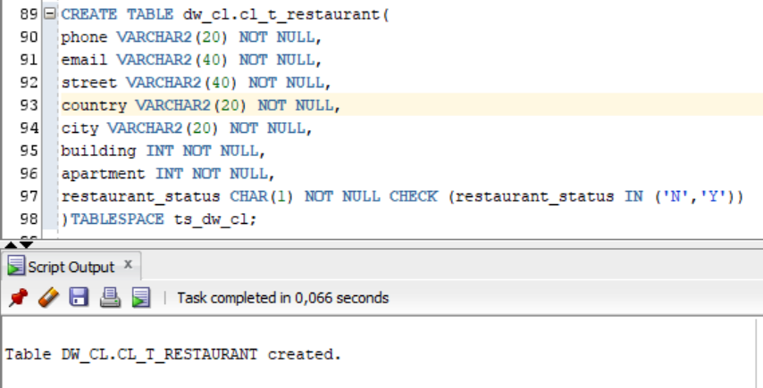

1. create table dw_cl.cl_t_transaction

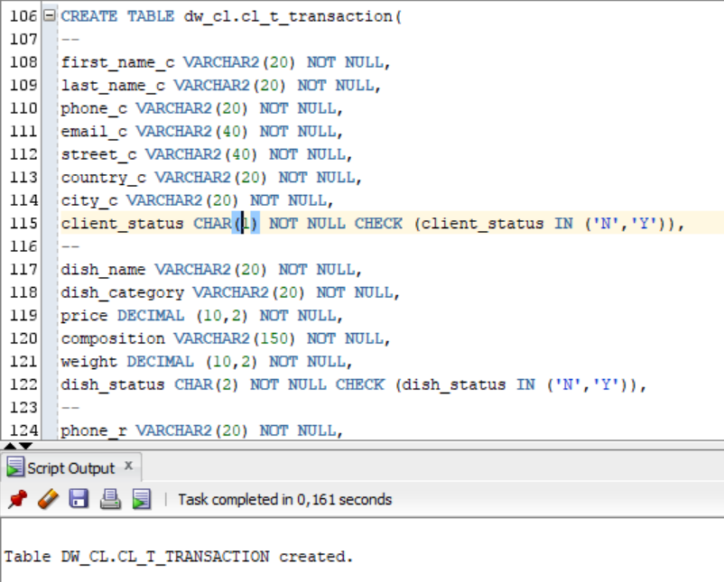

Create all necessary stored procedure for moving all data from storage area to cleansing layer. The main task of these procedures is to get rid of invalid data (that is, remove null values).

1. create package pkg_etl_clients_cl and stored procedure load_clean_clients

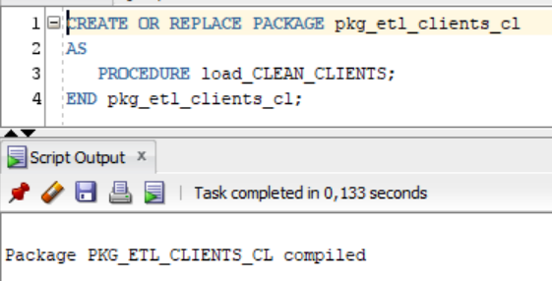

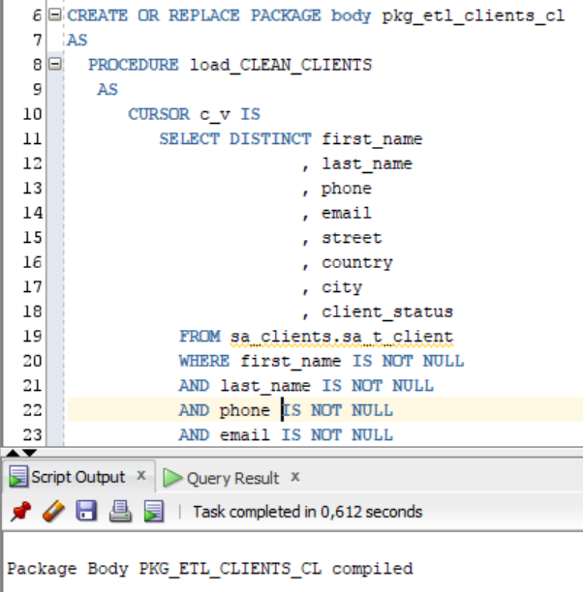

1. create package pkg_etl_dishes_cl and stored procedure load_clean_dishes

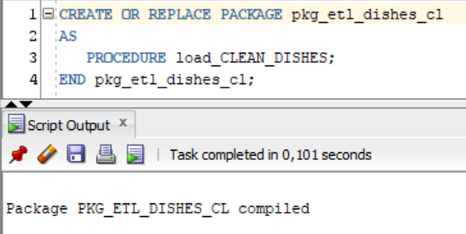

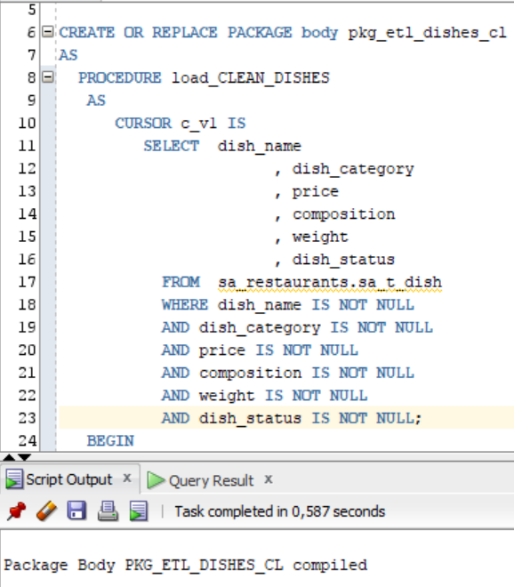

1. create package pkg_etl_employees_cl and stored procedure load_clean_employees

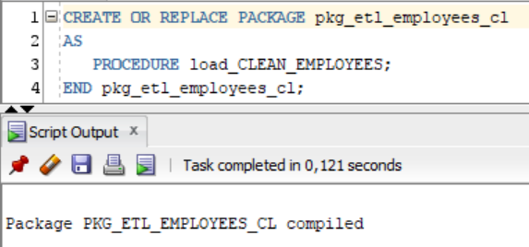

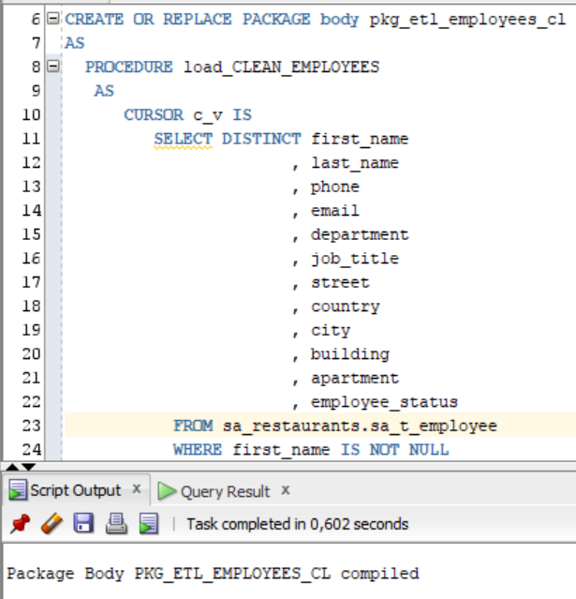

1. create package pkg_etl_gen_priods_cl and stored procedure load_clean_gen_periods

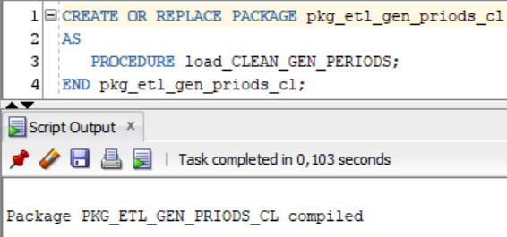

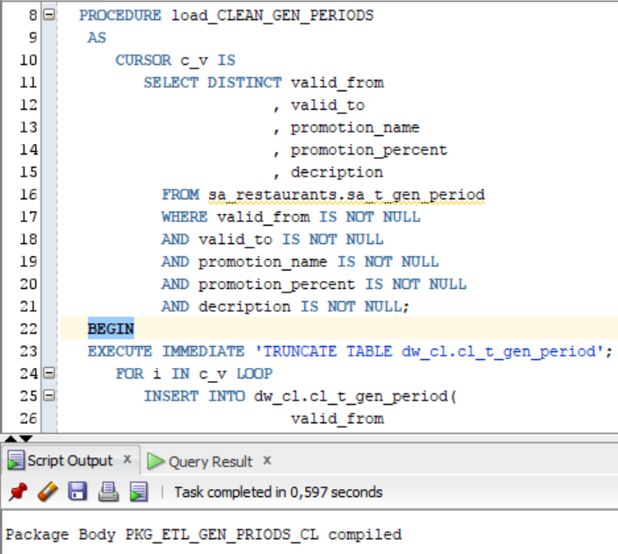

1. create package pkg_etl_payment_methods_cl and stored procedure load_clean_payment_methods

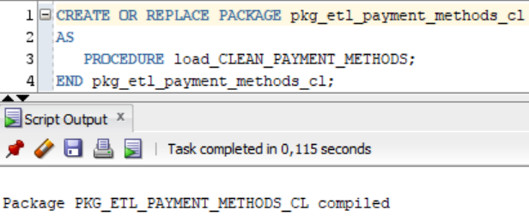

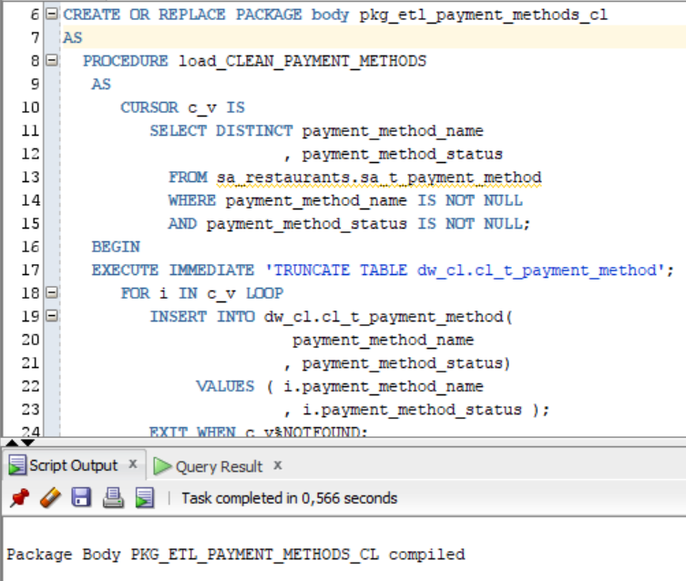

1. create package pkg_etl_restaurants_cl and stored procedure load_clean_restaurants

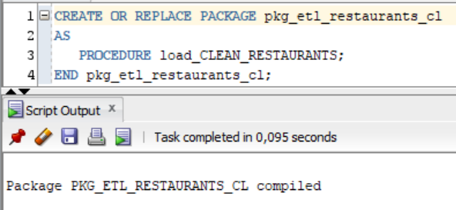

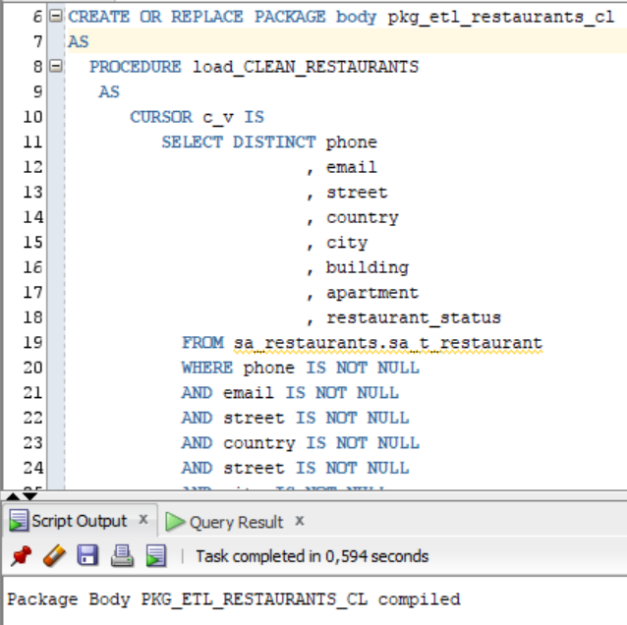

1. create package pkg_etl_transactions_cl and stored procedure load_clean_transactions

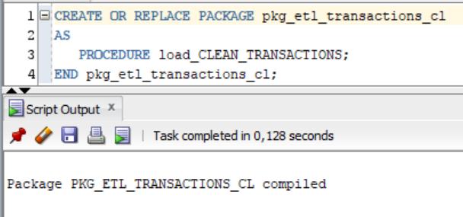

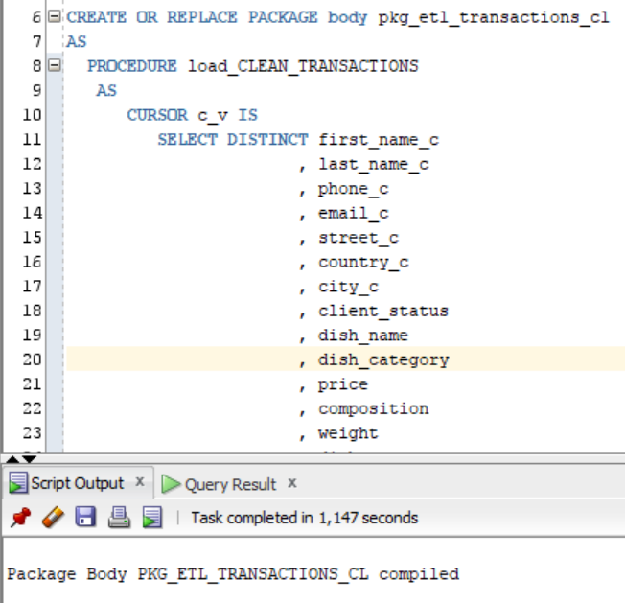

Run all procedures:

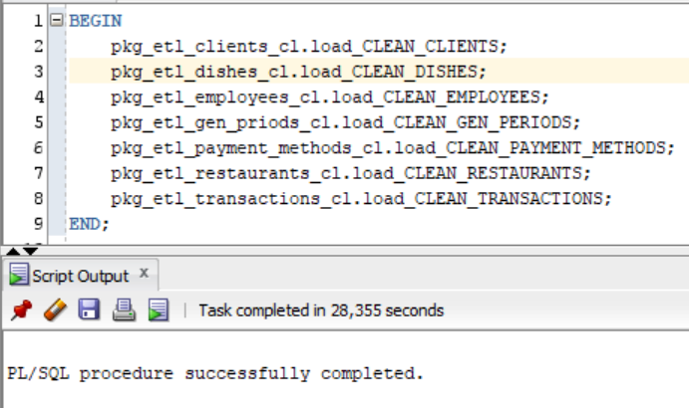

Select data from tables on cleansing level:

1. dw_cl.cl_t_client

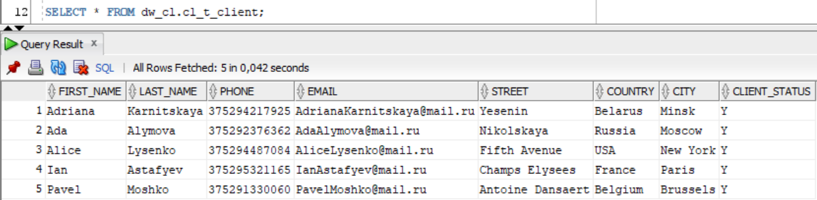

1. dw_cl. cl_t_dish

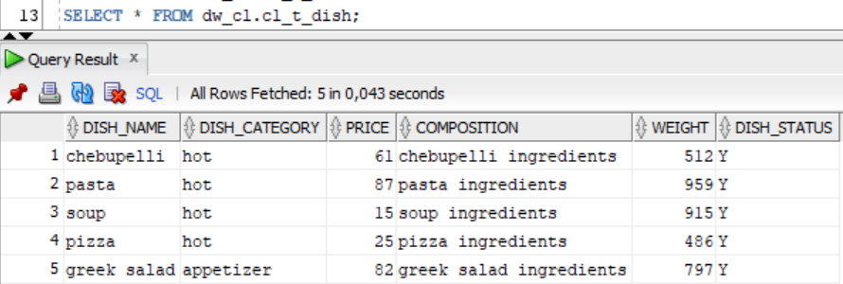

1. dw_cl. cl_t_employee

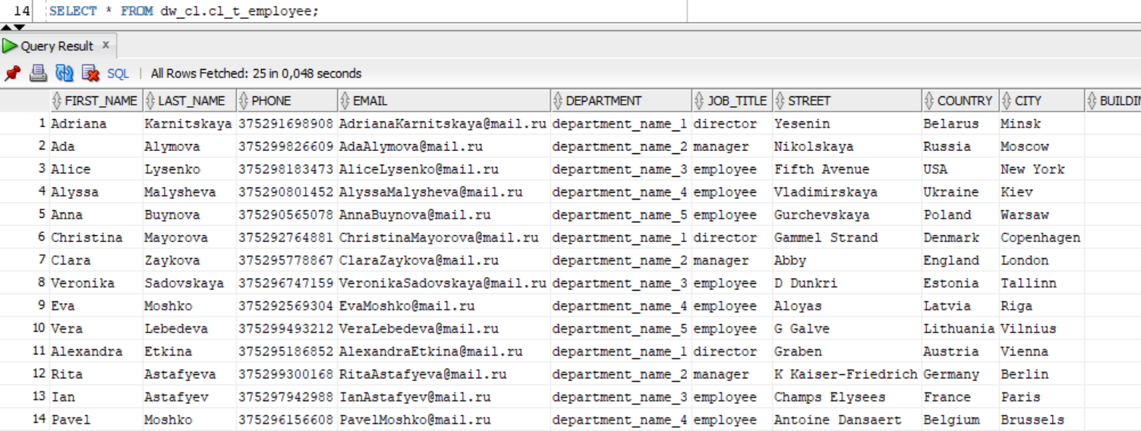

1. dw_cl. cl_t_gen_period

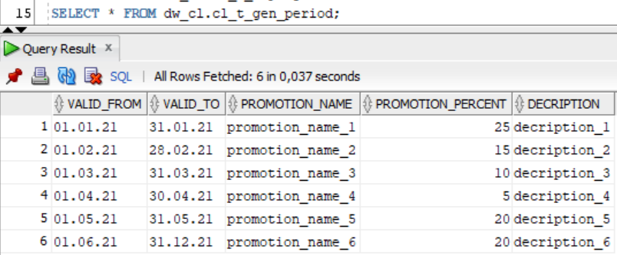

1. dw_cl. cl_t_payment_method

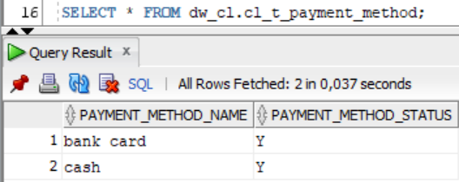

1. dw_cl. cl_t_restaurant

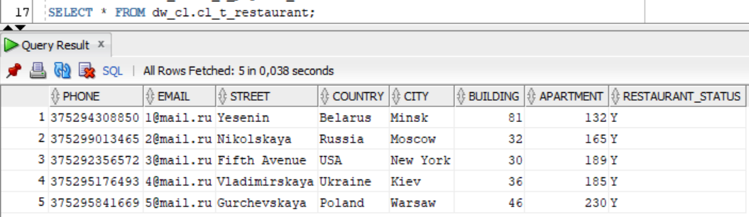

1. dw_cl. cl_t_transaction

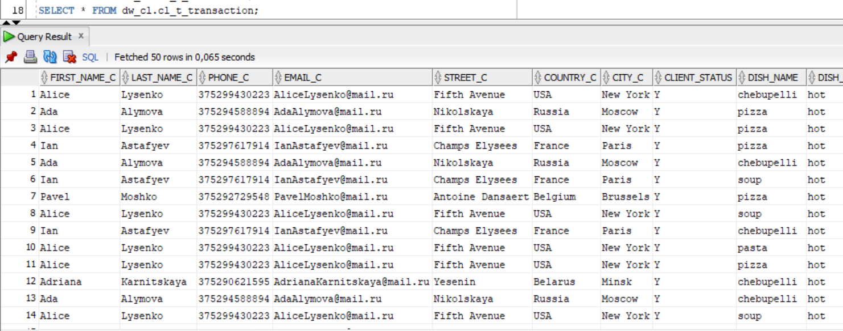

Create all necessary tables and sequences for the DW layer from the DW_DATA user in the ts_dw_data_01 tablespace:

1. create table dw_data.client_dimension and sequence seq_client_dim

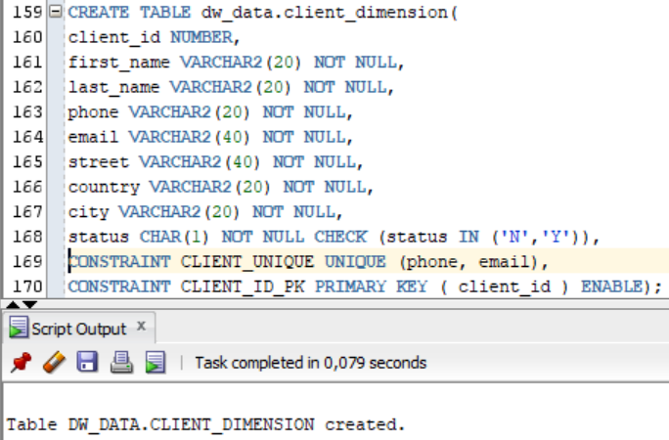

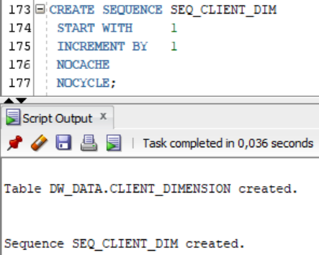

1. create table dw_data. dish_dimension and sequence seq_dish_dim

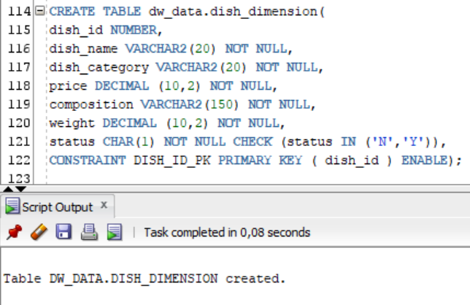

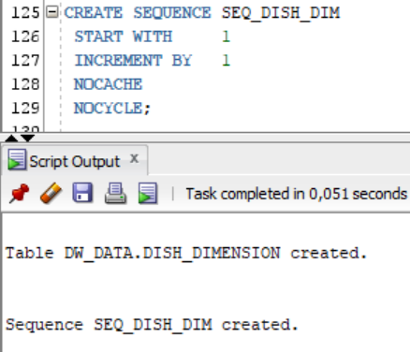

1. create table dw_data. employee_dimension and sequence seq_employee_dim

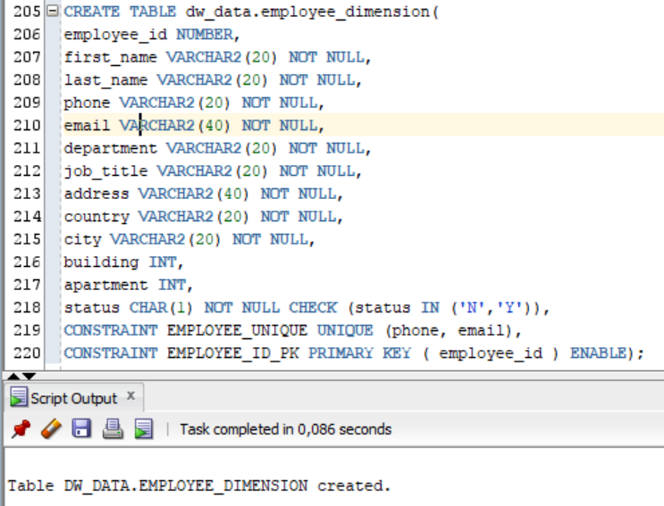

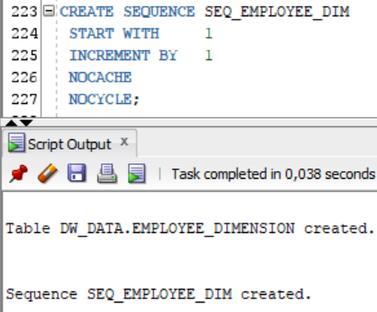

1. create table dw_data. dim_gen_period and sequence seq_gen_period_dim

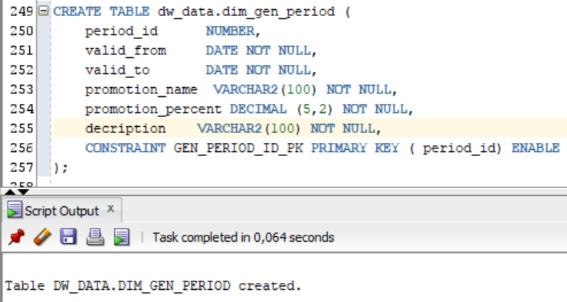

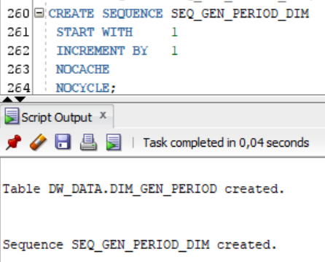

1. create table dw_data. payment_method_dimension and sequence seq_payment_method_dim

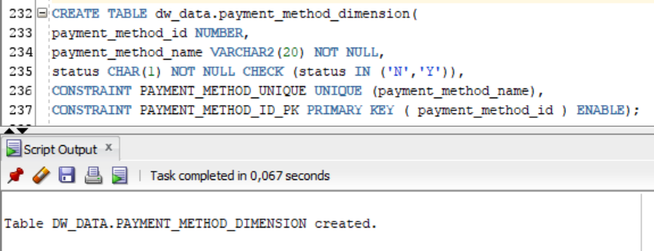

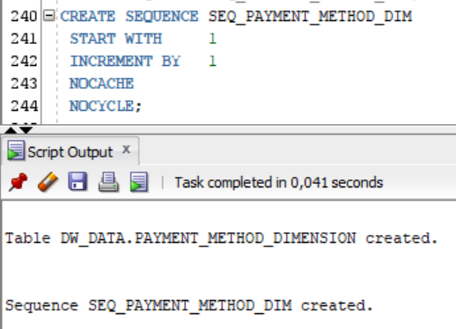

1. create table dw_data. restaurant_dimension and sequence seq_restaurant_dim

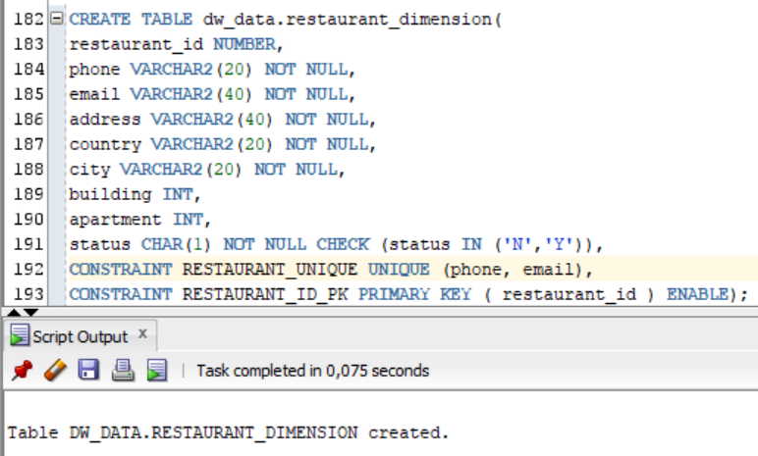

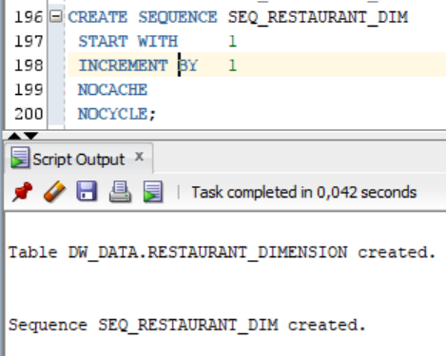

1. create table dw_data. order_fact and sequence seq_order_fact

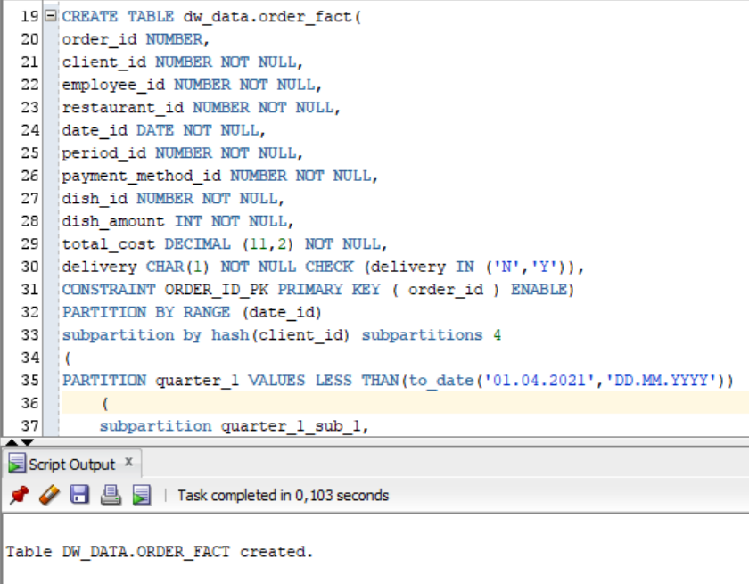

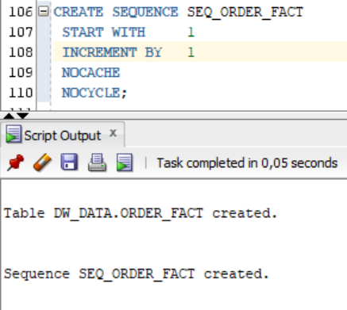

Add constraints:

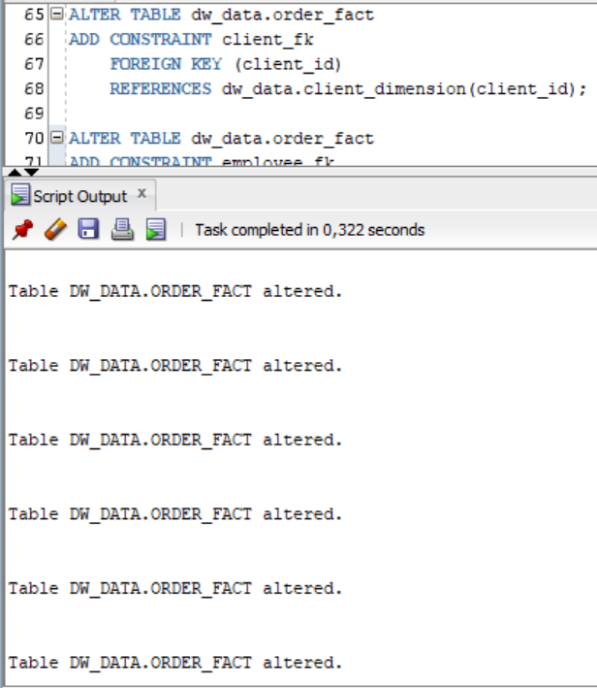

Create all necessary stored procedure for moving all data from cleansing layer to DW layer. The main task of these procedures is to convert natural keys to primary keys.

1. create package pkg_etl_clients_dw and stored procedure load_clean_clients_dw

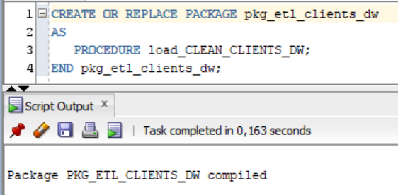

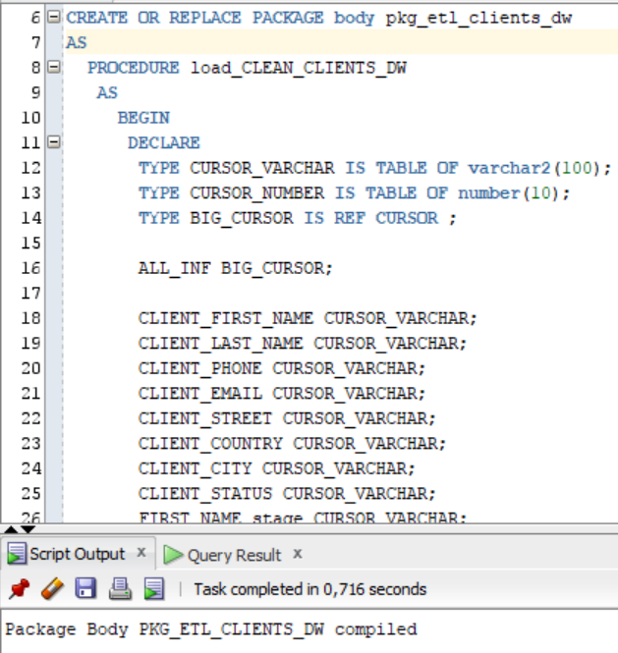

1. create package pkg_etl_dishes_dw and stored procedure load_clean_dishes_dw

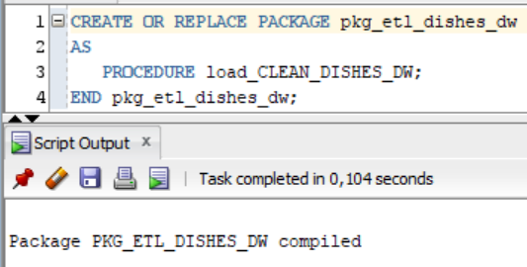

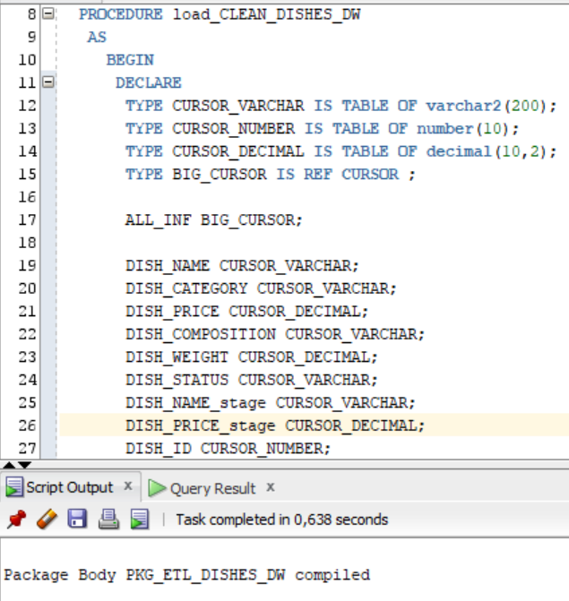

1. create package pkg_etl_employees_dw and stored procedure load_clean_employees_dw

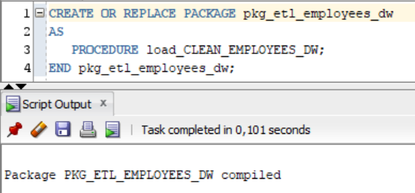

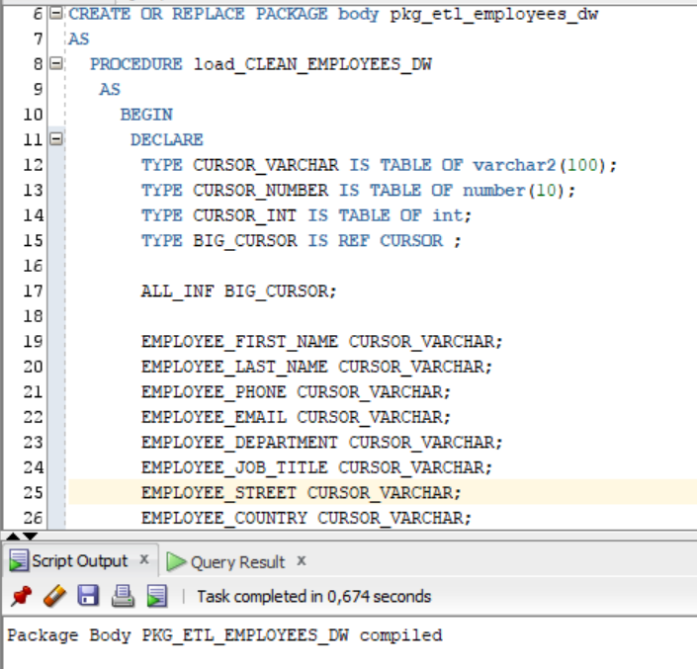

1. create package pkg_etl_gen_periods_dw and stored procedure load_clean_gen_periods_dw

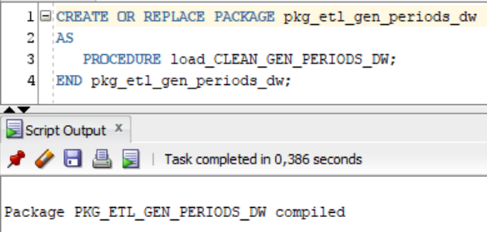

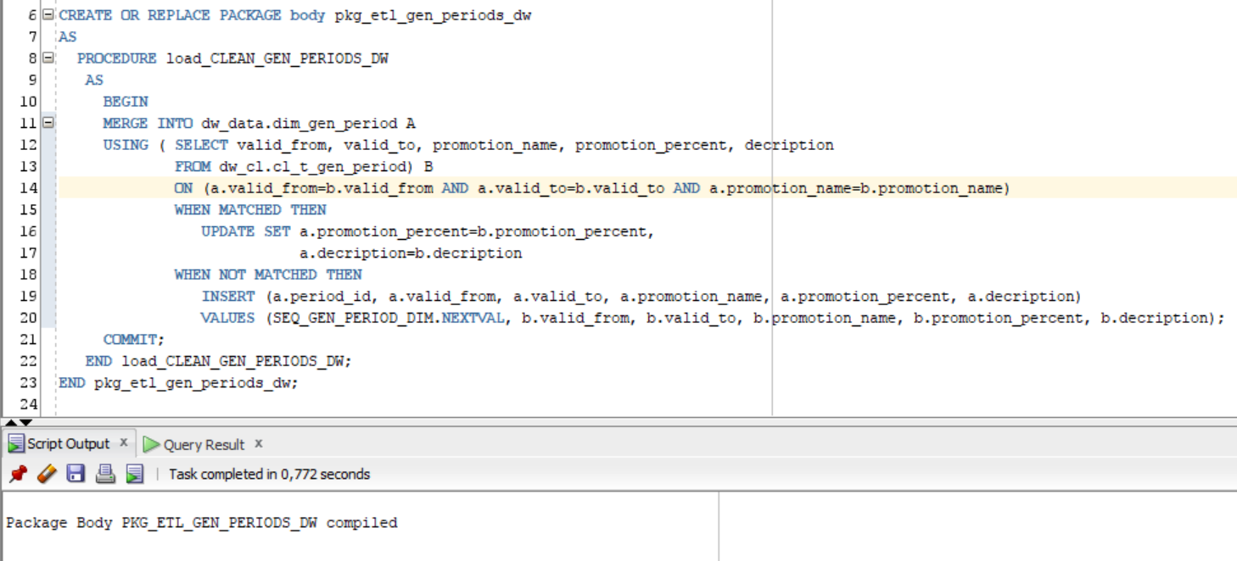

1. create package pkg_etl_payment_methods_dw and stored procedure load_clean_payment_methods_dw

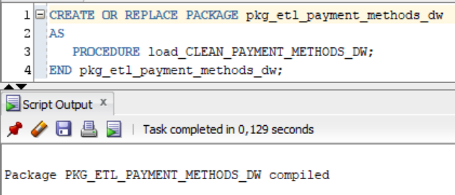

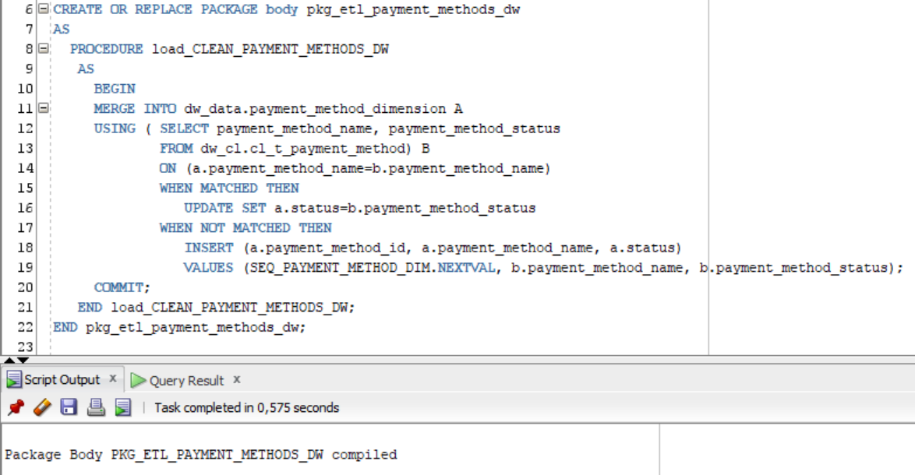

1. create package pkg_etl_restaurants_dw and stored procedure load_clean_restaurants_dw

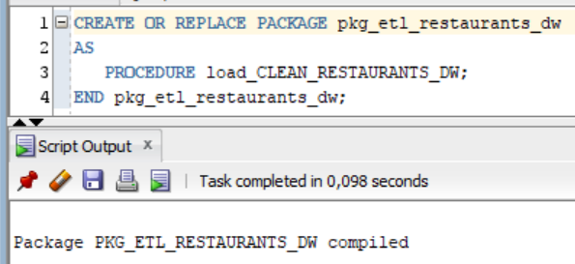

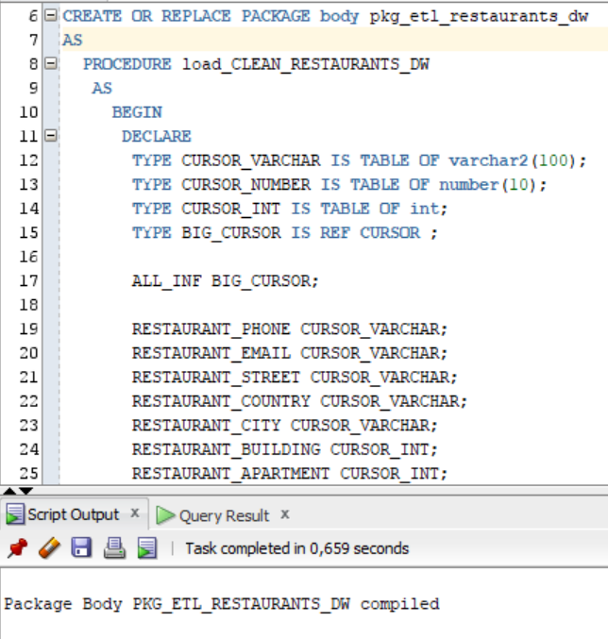

1. create pkg_etl_transactions_dw and stored procedure load_clean_transactions_dw

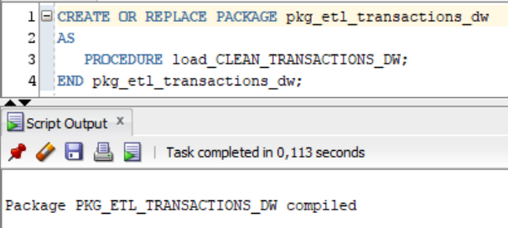

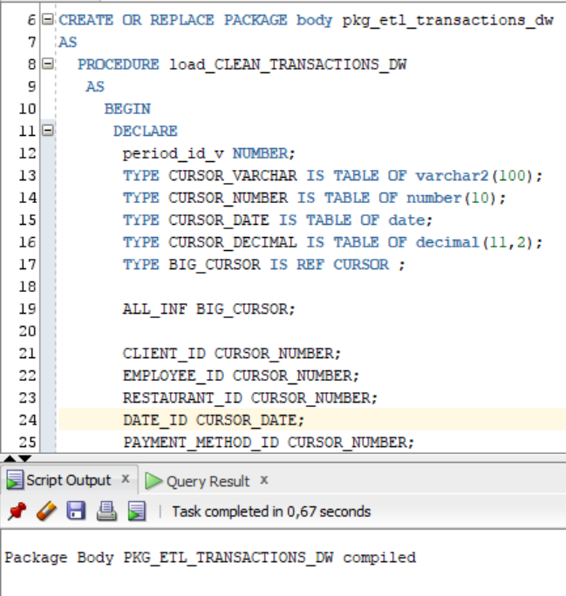

Run all procedures:

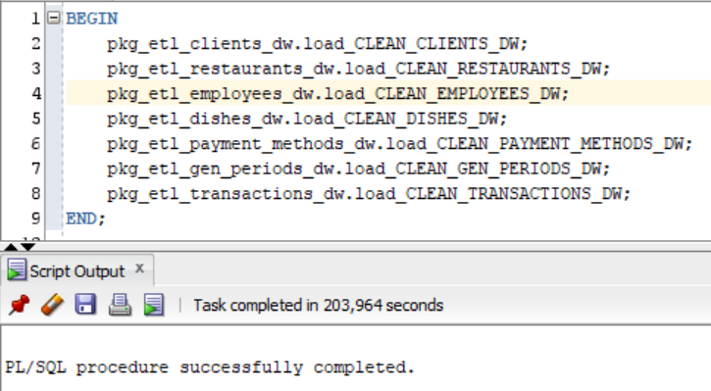

Select data from tables on DW layer:

1. dw_data.client_dimension

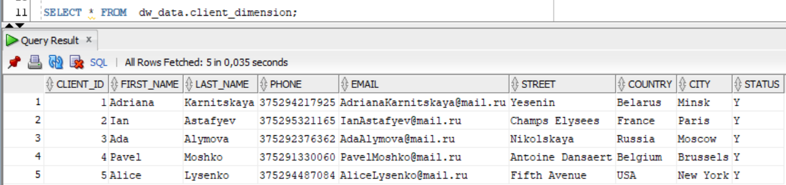

1. dw_data. restaurant_dimension

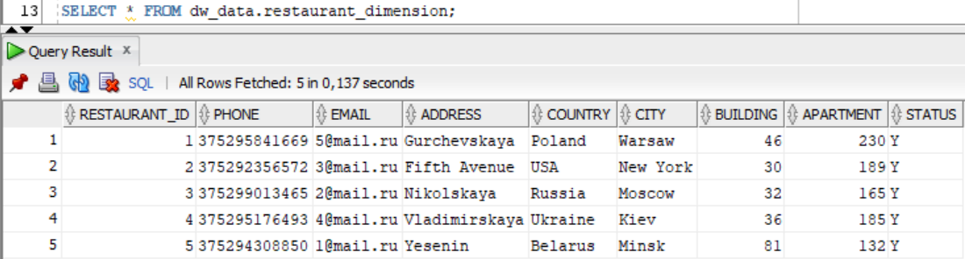

1. dw_data. employee_dimension

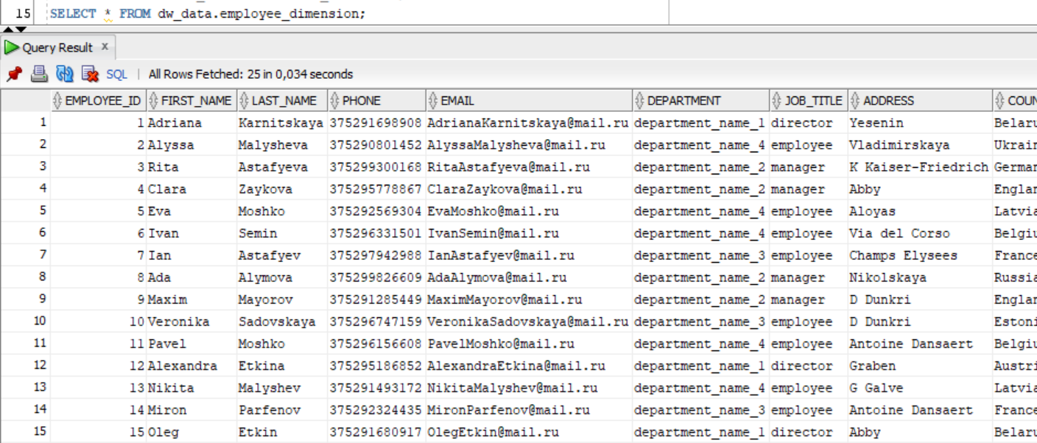

1. dw_data. dish_dimension

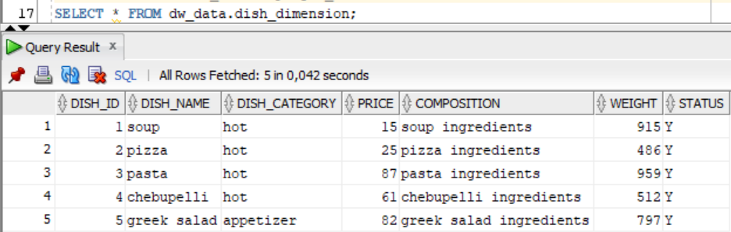

1. dw_data. payment_method_dimension

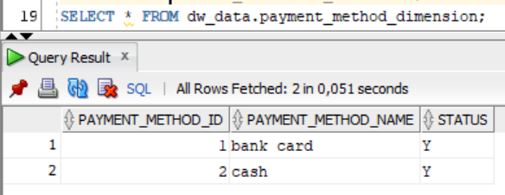

1. dw_data. dim_gen_period

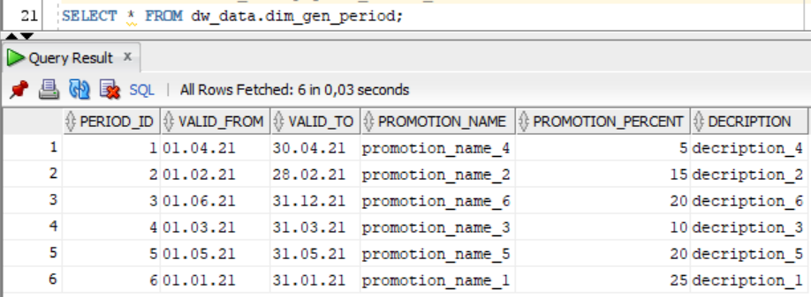

1. dw_data. order_fact

